The Boaire Handbook

The Boaire Handbook is compiled from various sources, both internal and external, for the purpose of educating and understanding the Clan MacColin and the people groups that are represented.
1st Edition
January 2019
Authors
Chief Steven Gillan
Cpt. Norman Montgomery
Lt. Lonny Rawlings
Michelle C. Rawlings

This pamphlet is not a complete book of rules. In fact, it is merely an introductory guideline designed to assist you as you journey into the areas of study necessary to understand Clan MacColin in its many facets. As time goes on, it is possible that the information herein will change with the needs of the Clan. It is our hope that through your studies, you will discover further interests, a deeper understanding of our histories and mission, and that these discoveries will, not only open doors for your continued participation within the MacColin Family but will bring you pride in your accomplishments and new-found knowledge.
-Authors

BOAIRE FAQ

What is a Boaire?
A: The word “Boaire” means “Cow-freeman” or “Cowlord.” Historically the Boaire were people who were socially above the simple peasant within the Clan. The Boaire were divided into six divisions in which the individual’s holdings of land and cattle determined where they stood on the social ladder. At the center of this ladder was the Boaire febhsa. It was a standing held by an individual, primarily a male member of a family, who owned land and 14 cumals of miltch cows. A cumal is equal to three cows and the word “miltch” means that the cows are “in milk,” milking, or have a calf at their side. So, a historical Boaire would have land, a small house, and 42 dairy cows. In MacColin, the term Boaire means, “one who does not borrow” and the achievement is open to anyone willing to put in the effort to complete the requirements. A Boaire will have a good understanding of MacColin and its various facets with well researched knowledge of a specific subject. The Boaire will also have enough possessions for themselves and several others.

What are the benefits of achieving the Boaire?
A: More responsibility! As with most standings within Clan MacColin, the Boaire makes the candidate a knowledgeable resource for the entire Family. As a Boaire you:

- Are a reliable spokesperson
- May Bushway for events
- Conduct educational presentations
- Could sponsor or mentor new members
- Boaire is a prerequisite for eligibility into a promotable class

Boaire Requirements

- Be a Clan member of at least three years (three Faires, setup to teardown). *

- Have enough items for at least three extra people other than yourself ... clothes, weapons, eating implements, etc.

- Read all required books and pass oral or written tests on the material in them.

- Know the basic knots and lashes, to be tested and to teach them.

- The creation of a whole or part of a large prop which must be approved by the Chief and which will become the property of MacColin.

- Do a term paper on a specific research subject.

- Know the family history, both ancient and modern.

- Know common Gaelic phrases and pike commands to execute and understand, with acceptable accent.

- Be able to perform, demonstrate, and teach the daily living, basic crafts, with names and uses of common tools.

- Have a well-developed persona that has been approved by the Chief.

- You may begin the Boaire process your 1st year with MacColin, but may not be considered completed until your 3rd season
CLAN MACCOLIN GOODS REQUIREMENTS

One of the requirements for Boaire outlined in this guide is the possession of a basic kit for at least three additional people other than yourself. Below are the current goods requirements and their descriptions. Your loaner kits should consist of cohesive pieces on this list. The kits can be for any three individuals. Consider who you are most likely to bring to an event and would need to dress. Contact the Costume Department for approvals.
Clan MacColin has a number of requirements for goods to make the living history family work. We must look correct and need to work. These are the items of a minimum kit, and all must be approved. In starting, you may arrange with individuals to borrow them, but must have them. In all things, natural materials are preferred for both performances, and in the case of garments, comfort.
Everybody is required to have:
Bowl -- Everyone must have an acceptable approved bowl, preferably hardwood.

Spoon -- You need a spoon of wood or horn to eat with.
Cup -- You must have a cup (wood, leather, or horn), and be able to carry it on your person on a march if you want community water; if not carried, you must have an approved canteen.
Belt Knife -- an all-purpose knife that can be used for eating and cutting.
Head Covering -- All are required to have head covering, male and female, for both living history social reasons and 20th century health reasons. For men this is usually a bonnet, and for women may be a biggins or kertch, preferably linen. (See Clan MacColin Clothing Guide)
Belts -- Men and women need to keep their clothing on, and a place to hang carried goods, for we have no pockets. For carrying pouches and cups, a crois is desirable, but probably is not strong enough to hold up your wool. A leather belt no wider than 1” is appropriate.
Knee-High Hose -- Hose are required by a number of our venues and are needed to keep our feet unblistered.
Shoes-- While the majority of our folk would not wear shoes unless in town or it was icy, we work in tetanus, broken glass, and splinter territory, and shoes are functionally and legally mandatory. New folks may use the black "kung foo" shoes until they can get "MacColin Flyers" or other approvable shoes.
Women are required to have:
Arisaide -- If (the only if for women here) you are a Scotts persona, you must have an arisaide, and optional if you're Irish.
Bodice -- All women must have a bodice. Other garments are in addition, not instead.
Lacing - - An unlaced bodice is a useful as high-top tennis shoes without laces.
Chemise or Leine -- You must have something appropriate under the bodice.
Wool Skirt -- Another basic required garment.
Underskirt -- Another basic required garment, at least one is required.
Bloomers -- Yes, we do require bloomers, and just ask a few ladies who have worked Faire why.
Men are required to have:
Ionar -- This is a basic men's garment, and a doublet is additional, and reserved socially.
Leines-- More than one leine is required, as you can get quite ripe before a Laundromat is available. They may be the shorter variety if you wear a kilt (at least thigh length), or ankle length if Irish.
Gauntlets -- Required of every man by both the Clan and the hands to avoid nasty splinters.
Short Truibhs -- If your character is Irish.
An 8 Yard Belted Plaide -- If your character is Scottish.
Other items become necessary very quickly, such as flashings to hold up your hose, a sporran or pouch for I.D., money, and keys. A notebook and pen are required for workshops and are generally necessary. As a required minimum , this is not all inclusive, list for other items may be required for events (i.e. your craft goods), it is just the minimum starting point for new members.
BIBLIOGRAPHY

This is a short list of books necessary for the study of the culture of the people that we represent and portray. Some of them are very hard to find, while others may be borrowed from other members. You should consult the MacColin Library for more availabilities.

First Semester Books

The Steel Bonnets: The Story of the Anglo-Scottish Border Reivers, George MacDonald Fraser, 1986, Collins Harvill, London, ISBN 0-00-272746-3

The Twilight Lords, Richard Berleth, 1994, Barnes and Noble, Inc. ISBN 1-56619-598-5
A good read, it is the primary survey for on our period.

Highland Folkways, I.F. Grant, 1961. Routledge and Kegan Paul Limited, London. Paperback: Birlinn Ltd., Edinburgh, ISBN 0-86281-250-X Mostly 18th century and later information, it is the best survey we have on the subject.

Irish Folkways, E. Estyn Evans, 1976, Routledge and Kegan Paul Limited, London, ISBN 0-71002-861-P
Mostly 18th century and later information, but the best survey we have on this subject area.

Cattle Lords and Clansmen: The Social Structure of Early Ireland, Nerys T. Patterson, University of Notre Dame Press, ISBN-13: 978-0268008000

The Great O'Neil, Sean O'Faolain, 1942, Reprinted 1992, Mercier Press, Dublin, ISBN 0-85342-769-0 Another essential history book best read after Twilight Lords. (Not required but is a good extra read).

The Scottish Highlanders: A Personal View, Charles Roy MacKinnon, 1984, St. Martain's Press, New York, ISBN 0-312-70505-0 A pleasantly written 1st semester read, without Celtic Twilight humbug.

Celtic Mythology, Promsias MacCana, 1970, The Hamlyn Publishing Group Ltd, London/New York, ISBN 600-00647-6 A very nice short survey and a roster of the mythological characters, both insular and continental, it is an essential introduction to the Rees book and helpful in reading the Tain.

More Advanced Reading

From Chiefs to Landlords: Social and Economic Change in the Western Highlands and Islands, c. 1493-1820, Robert A. Dodgshon 1998, Edinburgh University Press. Expensive yet very valuable and the newest authority on the Clan structure which includes an extensive description of land tenure. All necessary to understand our system.

Anglo-Irish Trade in the Sixteenth Century, Ada Kathleen Longfield, 1929, George Routledge and Son Ltd. London, Rare, valuable, rich in detail, it is necessary reading for the advanced family member.

Every-Day life on an Old Highland Farm, I.F. Grant, 1981, Shepheard-Walwyn, London, ISBN 0-85683-058-5 18th century, but as with our other life style selections the information reflects a much older social organization.

Elizabeth's Irish Wars, Cyril Falls, 1950, London A good Survey. Good detail and tidbits.

Celtic Heritage: Ancient Tradition in Ireland and Wales, Alwyn Rees and Brinley Rees, 1961, Thomas and Hudson. (Extra, not required) An essential read for the advanced clan member who has had more than passing exposure to Irish and Welsh myth cycles, with insights into the ways of art, literature, geography, politics, poetry, and character.

Mary Queen of Scots, Antonia Fraser, London, 1969. A very complete biography with very little sentimental stuff. Scholarly.

The Saints of Ireland, Ryan Darcy,Mary, St.Paul: The Irish American Cultural Institute, 1974. Recommended by Fr. Roibeard MacLochlainn +, esp. "Irish saints in Scotland", 71-88.

Crafts

Scottish Crafts, Ian Finlay, 1948, George G. Harrap & Co. Ltd. London, Not enough illustration, but worthwhile.

Traditional Scottish Dyes, and How to Make Them, Jean Fraser, Illustrated by Florence Knowles, 1985, Cannongate Publishing, Ltd. Edinburgh, ISBN 0-86241-1084

British Coracles and Irish Curraghs, James Hornell, F.L.S., F.R.A.I. 1938, Published for the Society of Nautical Research, Bernard Quaritch, Ltd. London. Rare and Valuable, it is The book on the topic.

Costuming

Tartans, Christine Hesketh, 1961, Library of Congress Catalogue #61-122200 Rare. Useful, although the printing quality is poor, and the number of color plates limited.

Old Irish and Highland Dress, With Notes on that of the Isle of Man, H.F. McClintock, Tempest, 1943, Dundalgan Press, Dundalk. Rare and valuable. The most authoritative source outside the primary sources.

Dress in Ireland, Mairead Dunlevy, 1989, Holms and Meir Publishers, Inc. 30 Irving Place, Ney York, N.Y. ISBN 0-8419-1269-8 A confused focus robs this work. Good illustrations, worth owning.

The History of Highland Dress, John Telefer Dunbar, 1962, Oliver and Boyd, London and Edinburgh. Rare and valuable. Not enough illustrations. Dunbar is the premier author in the highland area.

Patterns of Fashion: The Cut and Construction of Clothes for Men and Women c.1560-1620, Janet Arnold, 1994, MacMillian London Ltd. London. Excellent!

This short list is no way exhaustive. The serious clan member should keep a notebook on their readings to record questions and insights. Boaire candidates will be held to a level of knowledge respective of these publications. Remember, just because it is in print does not mean that the conclusions of the author are true or even useful. Develop a critical sense.
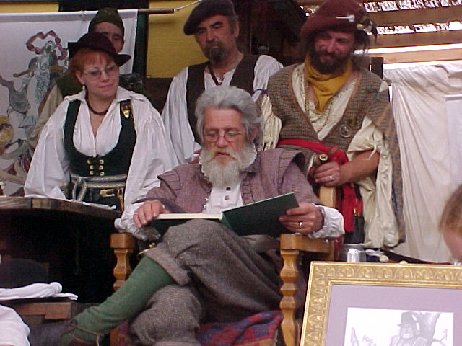

ROPE WORK
These knots, bends, and hitches, and some basic lashing take care of most of our needs.
Square knot (aka reef knot) | Sheet Bend (Weaver’s Knot) | Figure Eight Knot
Clove Hitch (double half hitch) | Tautline Hitch | Trucker's hitch
Bowline | Bowline on a Bight | Sheepshank
Half Hitch

Splices
Splices are strong and permanent. All of us need to know these, the basic ones.
Back splice: protects the end of the line (and your hands).
Eye splice: for a loop, often used for gates.
In-line splice: for joining of two lines into a longer one.
CREATING PROPS

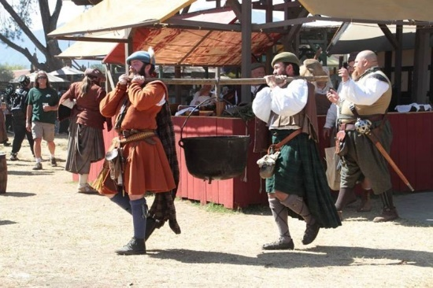
What are the requirements for my large prop?
A: The prop for your Boaire project should encompass your research so it should be well thought out, designed and attainable at your level. It should be coordinated with your sponsor and approved by the Chief to ensure it is appropriate for your line of study and use within MacColin. The creation of props often requires the ideas of many people, so don’t be afraid to ask questions and consult people who are skilled in their areas of craft or knowledge.

What kind of prop should I make?
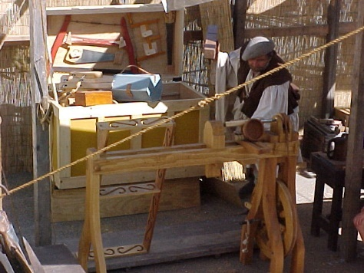
A: The prop that you provide becomes the property of MacColin therefore, a good way to look at your prop is to understand your field of study as well as the needs of the group. Let’s take the example of fishing for brown trout in Inverness during the 16th century. If your research was on this topic you might consider doing additional research on the tools that were used and then creating or finding useable replicas. It is good to build or craft your own props because it gives you an idea of the work that the people MacColin portrays had to do in order to feed themselves and create the things that they needed. That being said, you can employ the work of others as long as they meet the period requirements. Continuous feedback from your sponsor and the Chief will keep you on the path to a successful prop.

What kinds of props have already been created?
A: Take time to look around the encampment at any event. What tools are people using? What do people know about that reflect the things that they own and are surrounded by? Some of the props have been as small as a wagon, trebuchet or bow lathe and as elaborate as a cannon, a farm, a play, and even a library! A useable contribution that showcases your knowledge is the key.

Prop creation can be expensive. How can I deal with the expense?
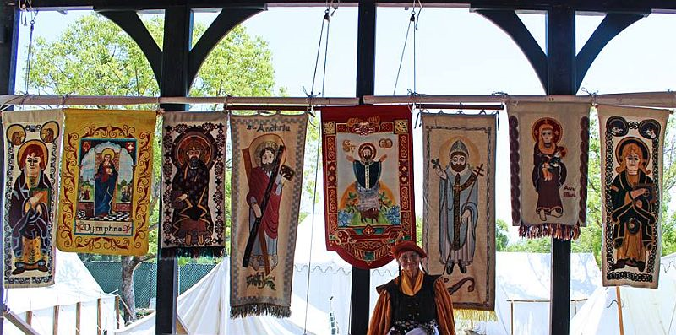
A: Props can be approached in a few ways. First, get your prop idea approved then you can figure out what materials that you will need and how much the item will cost. You can then decide if you will set aside money periodically and purchase all of the materials at one time or buy materials you will need in parts as you are able to afford it. You can also ask your MacColin kin to help you by donating parts or money. Another option is to join forces with one or more other Boaire candidates and share the expense of a large prop. Maybe as an individual you would have provided a box of fisherman’s tools, but as a group you created a small three-sided hut with the tools that create the nets and other items a fishing village would have.
TERM PAPER

What is a term paper?
A: A term paper is a written work primarily done in an academic setting, such as in high school or college. The paper should be written in an objective manner (with facts and without opinion). An excellent source is “A Writer's Reference with Exercises 7th Edition” by Diana Hacker (Author), ISBN-10: 0312601476. Papers should be in APA format. Owl Purdue online also has good references on APA writing format.

What should my paper be about?
A: In the case of Clan MacColin, the paper should be a work of research on a specific subject as it relates to the people, country, etc. of Ireland or the Scottish Highlands preferably during the 16th century. It is good to choose a topic that you are interested in and that you can find relevant source material. Example: You are interested in methods of fishing in the highlands during the 16th century. Your research might consist of brown trout harvesting in Inverness during that time period. Consult with your sponsor on possible topics and once you have narrowed your ideas down, present them to the Chief for approval.

How long should my paper be?
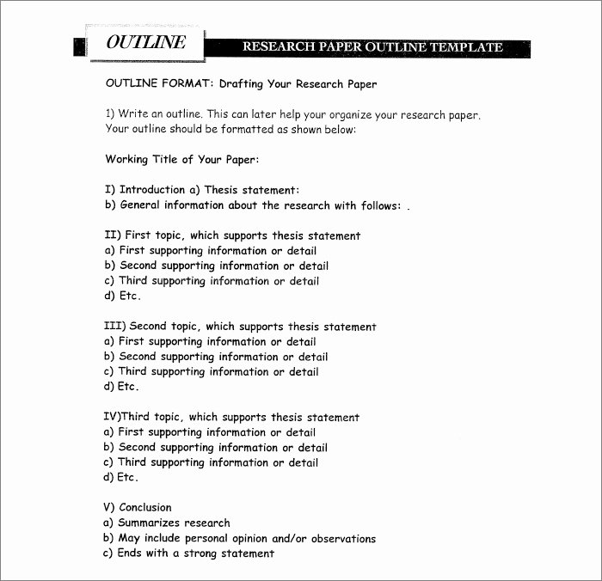
A: Unless specified, there are no set requirements for how short or how long a research paper should be. The average term paper is about five pages (single spaced) or ten pages (double spaced). The heart of the paper is the important part. Whether it is three pages or fifty, the information presented should be express ed clearly with proper sources and content. Paper should include footnotes from sources. There are examples to view for ideas. A basic method for research writing is included in this guide.
BASIC FORMULA FOR ESSAY WRITING

Choose a minimum of 3 important points about the main subject. (Example: Healthy Lifestyle for Cats)
    - Shelter.
    - Nutrition.
    - Enrichment.

THESIS: Even though cats are considered “easy keepers” they still have basic needs such as proper shelter, balanced nutrition, and daily enrichment. (Thesis includes all main points about the subject and states the entire purpose of the essay in one sentence).

Make sure you have at least one source per point. Do not use Wikis, encyclopedias, or dictionaries as sources. They can be used for their links to other sources, but not as a source itself.

Your essay should consist of at least five paragraphs: an introductory paragraph, three body paragraphs, and a concluding paragraph. For longer papers, increase information on point or add additional points. Additional points need to be incorporated into your thesis.

Prompt: This is what you are going to explain in your essay. It is the question that is being asked. In this example the question might be, “What do cats need in order to have a healthy lifestyle?”

1. Introduction Paragraph
- Attention Getter/Hook (i.e. rhetorical question, quote, statement of fact, etc…)
- Background information on subject
- A good place to put your thesis in a short essay, or until you are comfortable placing it elsewhere, is at the end of the introduction.
- Your intro can be broken down as such: 1 sentence that describes the topic. (Ex. Cats, having been domesticated for many years, have developed specific needs to maintain health). 1-2 clarifying sentences (through domestication humans have created a strong bond with cats and this has caused some things to change from the needs of the cat’s wild ancestors.) 1-2 tying in sentences (These changes are necessary for the relationship that people have with their cats, and these adaptations ensure that the animals can live long and happy lives.) THESIS: Even though cats are considered to be “easy keepers” they still have basic needs such as proper shelter, balanced nutrition, and daily enrichment.

2. Body Paragraph #1 This paragraph is for point A of your thesis (Shelter).
- Transition Word & Topic sentence- You can ONLY write about this topic sentence and nothing else. (Ex. Like most living beings, cats need basic shelter which can be both indoors or outdoors.)
- Quote/example #1 from source (Pick either a quote or an example. Make sure you cite your source after the text. (ex. “Cats are kings of their castles and they should be indoors,” (Last Name, First Initial OR Organization + Page number if in source is in print.(Rawlings, M. p.244))
- 1-2 sentences of analysis of the quote. Explain how the quote/example you selected demonstrates the topic. Why is indoor shelter important?
- Quote/example #2 (one or the other. If you used a quote before, use an example here. Unless specified as for APA and such you really only need one quote with in text citation PER BODY PARAGRAPH. (Shelters can be found outdoors too which is good for strays and ferals as well.)
- 1-2 sentences of analysis of the quote. Explain how the quote/example you selected demonstrates the topic. Why are outdoor shelters important?
- Provide explanation of the impact that this topic can have on the subject.

3. Body Paragraph #2 This Paragraph is for point B of your thesis (Nutrition)
- Transition Word & Topic sentence- You can ONLY write about this topic sentence and nothing else. (Ex. In addition to shelter, cats need a well-balanced diet to ensure their nutritional needs are met)
- Quote/example #1 from source (Pick either a quote or an example. Make sure you cite your source after the text. (ex. According to Cat Fancy Magazine,”15 out of every 20 cats are either obese or emaciated,” (Last Name, First Initial OR Organization + Page number if in source is in print.)(Cat Fancy, P.15)
- 1-2 sentences of analysis of the quote. Explain how the quote/example you selected demonstrates the topic.
- Quote/example #2 (one or the other. If you used a quote before, use an example here. Unless specified as for APA and such you really only need one quote with in text citation PER BODY PARAGRAPH.
- 1-2 sentences of analysis of the quote. Explain how the quote/example you selected demonstrates the topic.
- Provide explanation of the impact that this topic can have on the subject.
4. Body Paragraph #3 This Paragraph is for point C of your thesis (Enrichment)
- Transition Word & Topic sentence- You can ONLY write about this topic sentence and nothing else. (Ex. Once the cat’s dietary and shelter needs are met, owners should ensure that they have toys to play with and things to scratch.)
- Quote/example #1 from source (Pick either a quote or an example. Make sure you cite your source after the text. (ex. “You will lose your furniture to the shredding machines if you don’t buy a cat tree.)(Johnson, M. Interview)
- 1-2 sentences of analysis of the quote. Explain how the quote/example you selected demonstrates the topic.
- Quote/example #2 (one or the other. If you used a quote before, use an example here. Unless specified as for APA and such you really only need one quote with in text citation PER BODY PARAGRAPH.
- 1-2 sentences of analysis of the quote. Explain how the quote/example you selected demonstrates the topic.
- Provide explanation of the impact that this topic can have on the subject.
5. Conclusion Paragraph
- Restate your thesis statement
- Include information about how these topics about the main subject are important. DO NOT ADD NEW INFORMATION
- Final Remarks/add in theme (no opinions).
- Release (Cats are deserving of all of these things and more for as long as they allow us into their lives.
Read this and follow point by point. It will help. Promise.
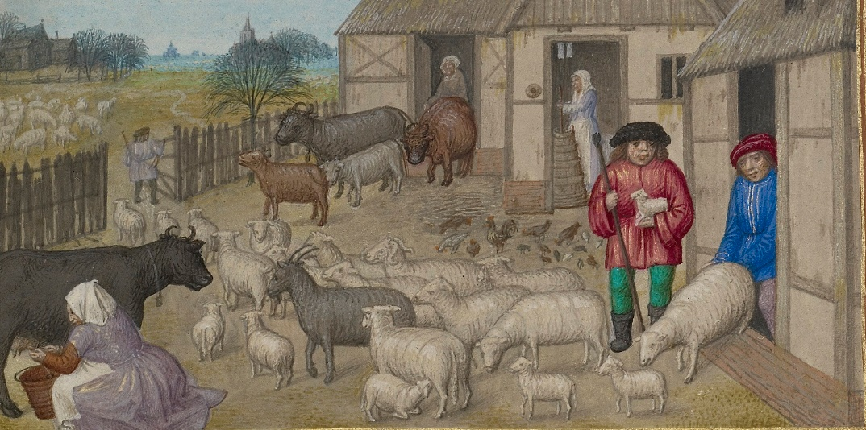
If you have questions at any time during the process, contact your sponsor, household head, or get help from a member with experience in writing. DON’T LET THIS GET YOU DOWN! THERE ARE PEOPLE WHO CAN HELP!

FAMILY HISTORY: BOTH ANCIENT & MODERN

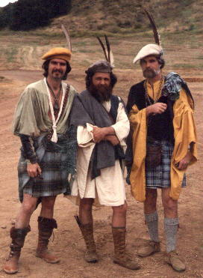
How did Clan MacColin begin? What is the story behind MacColin’s parent clan? Who are the Chiefs and their wives? What significant contributions have they made? Who was Phyllis Patterson? What was the Great Oak?

These are just a few questions you can consider when learning about Clan MacColin in modern times. Many of these, and a more, can be answered by listening to the stories the Old Timers tell, conduct interviews with long time members, Officers, and the Chief. Though Clan MacColin is based on 16th century history, in the forty plus years since its inception, the Family has become its own dynamic living culture. Many of the people who have been members for a significant number of years have dedicated countless hours and made sacrifices in order to do the things that they do. Take the time to call, email, and sit down with your Kin and ask questions about the “old days.” Find out how the Officers and Duine Uasal earned their positions. Ask the crafts people who mentored them and how they learned. Ask about the significance of Memorial. You are sure to be enlightened.
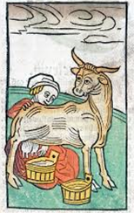
The history of the people that are portrayed by Clan MacColin is just as fascinating and deserves, at the very least, a moderate amount of study. An excellent place to begin is in reading the books listed in the bibliography. Take notes. Watch videos specific to the people during and around this time period. Go to museums with items representative of the culture. Speak to curators. Write letters to museums overseas. Speak to people who have done the studying and get ideas for references to seek out.

Some of the subjects that you might find interesting (and necessary) are:

- Land Tenure
- Trade
- Politics
- Farming & Food Production
- Clothing

Speak to your sponsor for more subjects and specific areas to focus on. It is possible that a study guide may be available on these subjects.
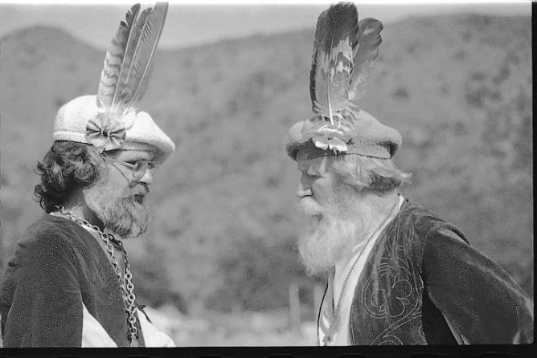

COMMON GAELIC PHRASES & PIKE COMMANDS

Basic Gaelic
Gaelic - Pronunciation – English
Dia dhui t ( dee-uh guht) Hello ("God to you").
Conas ta tu? ( coh-nuss taw too ) How are you?
Ta me go maith (taw meh goh mah) I am well.
Ma se do thoil e (mah shay doh hahl ay) Please.
Go raibh maith agat (guh rev mah ah-guht) Thank you.
Gaibh mo leith sceal (gwiv moh leh shkayl) Excuse me.
Buiochas le Dia (bwee-uh-khuss leh dee-uh) Thanks be to God.
Dia linn! (dee-uh ling) (Blessing when sneezing)
Slan abhaile (slawn ah-wahl-yeh) Safe home.
Fan amach na loca (fun aw-makh naw loh-khuh) stay away from the lake
Tog go bog e (toag goh buhg ay) Take it easy.
Uisge (oos-keh) water
Uisgebeatha ( oos-keh-baw-he ) whiskey (water of life)
Tar anseo (taar ahn-show) come here
Ceann alt (Kyan elt) knuckelhead
Dean deifir (jen jeffer) hurry up
Duisidh! ( doo- shee) wake up!
Na bac leis (nah bakk lesh) Never mind.
Dean e! (day-n ay) Do it !
Bi curamach! (bee coor-ah-mahkhl) Be careful.
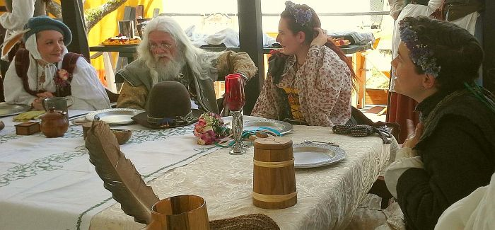

TEN MOST OFTEN USED PIKE COMMANDS

Each command is listed in Gaelic, as used, followed by a translation and pronunciation.
1. | A SLEIGH CO THIONAILIBH | PIKEMEN, FALL IN  (ASHLAY KA TUNE A LEAVE)
2. | TOGAIBH A SLEIGH | CARRY PIKES  (TOGA EEVE ASHLAY)
3. | OCHIONA GRAESIBH | GENTLEMEN, FORWARD MARCH  (AWK E OWNA GRAY SEIVE)
4a. | AOMAIBH A SLEIGH [A STEACH] | PORT PIKES (TO INSIDE)  (ALMEVE ASHLAY [A SHTECK])
4b. | AOMAIBH A SLEIGH A MACH | PORT PIKES TO OUTSIDE  (ALMEVE ASHLAY A MACH)
5. | DIONAIBH A SLEIGH | CHECK PIKES  (DEON EVE ASHLAY)
6. | A SLEIGH DIROCHAIBH | PIKEMEN LINE IT UP!  (ASHLAY DROCK HEAVE-OR JUST: DROCK HEAVE)
7. | A SLEIGH STADAIBH | PIKEMEN STOP  (ASHLAY STADEEV)
8. | SILAIBH A SLEIGH | REST PIKES  (SHE LEAVE ASHLAY)
9a. | FHLANNCAERANN A MACH | FLANKERS OUT  (FLANKREN A MACH)
9b. | FHLANNCAERANN A STEACH | FLANKERS FORWARD  (FLANKREN A SCHTICK)
9c. | FHLANNCAERANN ALMOUI | FLANKERS IN  (FLANNKREN ALM WE)
10. | ANEESH! | NOW!  (ANEESH!)
It is easiest to learn the commands by doing them, learning the command as an action itself, without trying to translate them first which often leads to confusion.
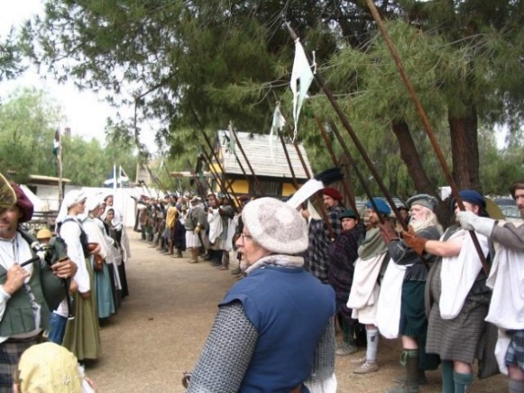
Drills are often performed during events so try to participate when able. You may speak with the 1st Sergeant or an Officer about offering drill times outside of events as well.

DAILY LIVING & BASIC CRAFTS

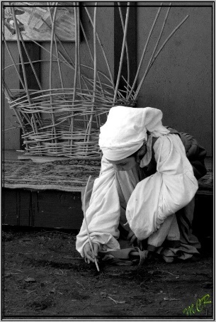
Clan MacColin prides itself on the knowledge and creative abilities of its members and it is no secret that MacColin has some of the most well-studied and talented individuals in the re-enactment community. It is what makes the MacColin Family the best there is.
The daily living and crafts of MacColin are, like most things, two-fold; historical and modern. Demonstrating something as simple as sawing a piece of wood can be an exercise in familiarity by knowing the differences in the tools that MacColin uses today versus the tools that would have been used by our predecessors in the 16th century. The same can be said for kitchen prep, cooking, and meals for the Clan. The types of food and utensils that would have been used historically are different than what is used today. There are also considerations in how meals, clothes, and possessions are distributed and allowed based on the Sumptuary Laws. This applies to both the historical aspects as well as the modern.
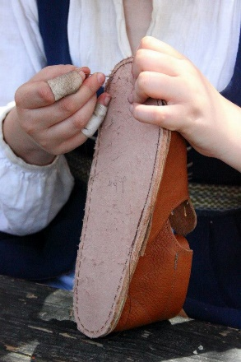
Some of the areas of daily living that can be explored are:
- High Table (Family and guest placement, service order, and protocol)
- Kitchen work (Meal prep, supply information, and organization)
- Parades, processions, visitations
- Social structure
- Military
- Building
- Shows and gigs
Take time (and notes) to speak to the people that are familiar with the details in these areas. Your sponsor can help point you towards the right people.
Crafts are typically for anyone who wishes to learn them. Here, the same ideas as the daily living apply. Knowing the tools that are used for the various crafts and the differences between their use historically, in modern times, and in some cases, theatrically.
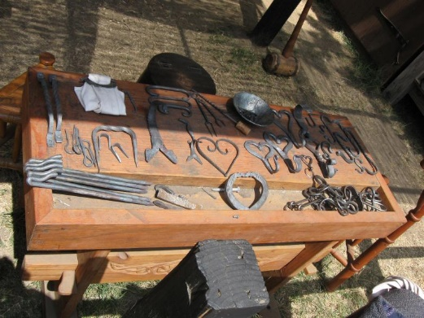
Here are some of the crafts you can seek out:
- Textiles (spinning, weaving, sewing, embroidery)
- Leatherwork
- Blacksmithing
- Woodwork
- Nalbinding
- Music, song, and dance
Spend time with the different craft people and talk about their work, how it is done, and ask to try it out. Even a single opportunity can give you the experience you need to be a well-rounded Boaire.

PERSONA WORKSHEET FOR CLAN MacCOLIN

Facts About My 16th-Century Persona:

1. Persona Name: _____________________________________________________________
(Character's given name, descriptive, & patronymic. Examples: Iain "Dubh" MacEoghan = Ian "the dark," son of Eoghann; Fiona nic Ciaran Gaobh = Fiona, daughter of Ciaran the Smith)

2. Persona Age _____ Birthdate (optional) ___________________________________
(Beyond adolescence, choose an age younger than you actually are - people wore out early! As a birthdate you would most likely give a season, a festival, or a saint's day, and note the year in terms of some local event.)

3. I belong to the household of ______________________________________________
(Also note duties or position in that household, if applicable: tenant, ghillie, seamstress, etc.)

4. My persona holds the following position, rank, or office(s) in Clan MacColin (also give 20th-century rank):
____________________________________________________________________________

5. My persona has these notable personality traits and physical characteristics:
____________________________________________________________________________
____________________________________________________________________________

6. My persona has these notable skills: ___________________________________________
(My persona trades on these skills: _______________________________________________)

7. My persona's derivation is __________________________________________________
(MacColin Scottish-native of Glenderry; other Scottish-indicate origin; MacColin Irish-how related, native or incomer? other Irish-indicate how joined Clan; mixed-native or incomer? outlander-origin? how and why joined?)

8. Three most notable events in my persona's life, and age when they occurred:
____________________________________________________________________________
____________________________________________________________________________
Examples: Handfasting or marriage, death of parents, first hunt or raid, moving from Ireland, etc.)

9. My persona is related to the persona's of the following other Clan members:
Name (16th & 20th century) Relationship
____________________________________________________________________________
____________________________________________________________________________
____________________________________________________________________________
____________________________________________________________________________

Examples: Aine Og nic Conor (Ann Jones) - handfast; Coineach mac Colm (Bill Brown) - first cousin. Ask your Household Head, your Clan relatives, and the Chronicler for persona help at any time. Suggestion: Use pencil, for easier changes! If you need more room, use the back of this sheet.

Please make three copies of the finished worksheet. Give one to the Chronicler; the second goes to your Household Head; the third is for you to keep for reference. Please notify the Chronicler and your Household Head of any changes.

DIRECTORY OF CONTACTS

Steven Gillan
Chief of Clan MacColin
Phone: (714) 454-9481
Email: ColinChief@hotmail.com
Grad Flaith Household: Glenderry

Jessica Gibbs
Taniste/1st Officer/Irish Dance/Shows
Cell: (562) 245-8814
Email: Irishmoon76@yahoo.com
Grad Flaith Household: Taniste

Norman Montgomery
Captain/An Fear Sporran
Phone: (714) 557-0794
Email: Odo@MacColin.com
Grad Flaith Household: Tournaig

William (Bill) Voorhes
Captain/An Marshall Tieg
Phone: (805) 404-1250
Grad Flaith Household: Slaggen

Elizabeth McClure
Captain
Phone: (805) 404-1250
Email: mclizard17@sbcglobal.net
Grad Flaith Household: Achnasheen

Bill Jacobs
Captain/Quartermaster
Phone: (310) 836-8399
Email: (Cathy) cjacobs@csudh.edu
Grad Flaith Household: Kinlochewe

Lonny Rawlings
Lieutenant/Chief of Staff
Cell: (760) 524-6861
Email: Rawlingslt@gmail.com

Brownwynn Rawlings
Phone:sionnachtach@gmail.com
Email: (562) 242-6020
Grad Flaith Household: Eilein Ewe

Chief (Tighe) Sidnam
Recruitment
Phone: (805)320-9490
Email: maccolinrecruitment@gmail.com
Grad Flaith Household: An Doire

Regina Lawson
Costumes/Social Secretary
Phone (Cell): (818) 439-6193
Phone (Home): (818) 773-0375
Email: reginalawsonv@gmail.com
Household: MacAndrieu

Cathy Jacobs
Kitchen Business/Membership Paperwork
Baintighe Kinlochewe
Phone: (310) 836-8399
Email: cjacobs@csudh.edu

David Nelson
Warrant Officer/Slum Lord
Phone (Cell): (818) 522-7962
Phone (Home): (818) 248-8320
Email: godzuki5@gmail.com

Brian Howard
1st Sergeant
Phone: (714) 308-4180 (Text Preferred)
Email: Brianruadh@gmail.com

Terri Nelson
Lance Pasado/Event Passes & Paperwork
Phone (Home): (818) 248-8320
Email: CMCPaperGoddess@gmail.com

Amy Myrtetus
Sergeant/ Medical Corp/Store
Phone: (626) 864-6829
Email: faeamy@gmail.com

Shelley Montgomery Puente
Highland Dance Instructor
Phone: (818) 458 -6628
Email: Everythingceltic@rocketmail.com

Jeanne Roberts
Personas & Family Info
Email: pjgwinn42@gmail.com

Kit Whitten
Clan Library
Email: foxenboxen@gmail.com

RESOURCE CITATIONS

Bowline on a Bight.” 2020 Site, 2018, www.2020site.org/knots/bowlineonbight.html.

De Heere, Lucas. “Savage Scotsman.” Www.pinterest.com, 2018,
i.pinimg.com/originals/16/f2/1a/16f21a8653f6e2d750ce173ae874b628.jpg.

Getty Museum. “Farm Animals, Milking, and Buttermaking; Zodiacal Sign of Taurus.” The Iris, The Getty Museum,
Scotland, 2018, blogs.getty.edu/iris/we-tried-medieval-divination-and-it-worked/.

Gillan, Steven. “Clan MacColin of Glenderry A Re-Creation in Living History.” Clan MacColin , Norman Montgomery,
www.maccolin.com/

Rawnjournals. “Reasearch Outline.” penetratearticles.info, 2018, http://penetratearticles.info/apa-outline-format-template/apa-outline-format-template-awesome-ouline-format-heartpulsar/

Staff, EasyBib. “The Free Automatic Bibliography Composer.” EasyBib, Chegg, 1 Jan. 2019,
www.easybib.com/style/mla8/photo-citation.

“Trucker's Hitch.” Zahirnews, 2018, zahirnews.com/truckers_hitch_knot_diagram.php.

Wellcomeimages. “A Woman Milking a Cow, Woodcut, 1547.” Http://Catalogue.wellcomelibrary.org/Record=b1295450,
Https://Wellcomeimages.org/Indexplus/obf_images/4f/8f/460d5e5d02c0b0a6f21296fc218d.Jpg , 2018.

NOTES
____________________________________________________________________________________________________________________________________________________________________________________________________________________________________________________________________________________________________________________________________________________________________________________________________________________________________________________________________________________________________________________________________________________________________________________________________________________________________________________________________________________________________________________________________________________________________________________________________________________________________________________________________________________________________________________________________________________________________________________________________________________________________________________________________________________________________________________________________________________________________________________________________________________________________________________________________________________________________________________________________________________________________________________________________________________________________________________________________________________________________________________________________________________________________________________________________________________________________________________________________________________________________________________________________________________________________________________________________________________________________________________________________________________________________________________________________________________________________________________________________________________________________________________________________________________________________________________________________________________________________________________________________________________________________________________________________________________________________________________________________________________________________________________________________________________________________________________________________________________________________________________________________________________________________________________________________________________________________________________

NOTES
____________________________________________________________________________________________________________________________________________________________________________________________________________________________________________________________________________________________________________________________________________________________________________________________________________________________________________________________________________________________________________________________________________________________________________________________________________________________________________________________________________________________________________________________________________________________________________________________________________________________________________________________________________________________________________________________________________________________________________________________________________________________________________________________________________________________________________________________________________________________________________________________________________________________________________________________________________________________________________________________________________________________________________________________________________________________________________________________________________________________________________________________________________________________________________________________________________________________________________________________________________________________________________________________________________________________________________________________________________________________________________________________________________________________________________________________________________________________________________________________________________________________________________________________________________________________________________________________________________________________________________________________________________________________________________________________________________________________________________________________________________________________________________________________________________________________________________________________________________________________________________________________________________________________________________________________________________________________________________________

NOTES
____________________________________________________________________________________________________________________________________________________________________________________________________________________________________________________________________________________________________________________________________________________________________________________________________________________________________________________________________________________________________________________________________________________________________________________________________________________________________________________________________________________________________________________________________________________________________________________________________________________________________________________________________________________________________________________________________________________________________________________________________________________________________________________________________________________________________________________________________________________________________________________________________________________________________________________________________________________________________________________________________________________________________________________________________________________________________________________________________________________________________________________________________________________________________________________________________________________________________________________________________________________________________________________________________________________________________________________________________________________________________________________________________________________________________________________________________________________________________________________________________________________________________________________________________________________________________________________________________________________________________________________________________________________________________________________________________________________________________________________________________________________________________________________________________________________________________________________________________________________________________________________________________________________________________________________________________________________________________________________

